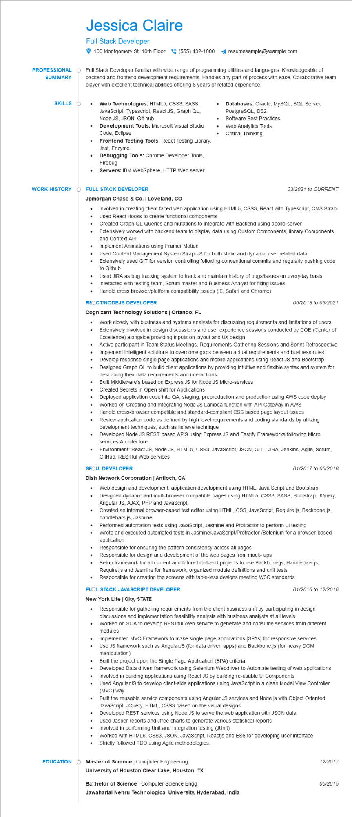
PROFESSIONAL
SUMMARY
Jessica Claire
Full Stack Developer
100 Montgomery St. 10th Floor (555) 432-1000 resumesample@example.com
Full Stack Developer familiar with wide range of programming utilities and languages. Knowledgeable of backend and frontend development requirements. Handles any part of process with ease. Collaborative team player with excellent technical abilities offering 6 years of related experience.
Web Technologies: HTML5, CSS3, SASS, JavaScript, Typescript, React.JS, Graph QL, Node.JS, JSON, Git hub
Development Tools: Microsoft Visual Studio Code, Eclipse
Frontend Testing Tools: React Testing Library, Jest, Enzyme
Debugging Tools: Chrome Developer Tools, Firebug
•
Databases: Oracle, MySQL, SQL Server, PostgreSQL, DB2
Software Best Practices
Web Analytics Tools
•
Critical Thinking
SKILLS O
•
WORK HISTORY
•
Servers: IBM WebSphere, HTTP Web server
Ò FULL STACK DEVELOPER
Jpmorgan Chase & Co. | Loveland, CO
•
03/2021 to CURRENT
Involved in creating client faced web application using HTML5, CSS3, React with Typescript, CMS Strapi Used React Hooks to create functional components
•
Created Graph QL Queries and mutations to integrate with Backend using apollo-server
•
Extensively worked with backend team to display data using Custom Components, library Components and Context API
Implement Animations using Framer Motion
Used Content Management System Strapi JS for both static and dynamic user related data
Extensively used GIT for version controlling following conventional commits and regularly pushing code to Github
Used JIRA as bug tracking system to track and maintain history of bugs/issues on everyday basis Interacted with testing team, Scrum master and Business Analyst for fixing issues
• Handle cross browser/platform compatibility issues (IE, Safari and Chrome)
REQCT/NODEJS DEVELOPER
Cognizant Technology Solutions | Orlando, FL
....
•
06/2018 to 03/2021
Work closely with business and systems analysts for discussing requirements and limitations of users Extensively involved in design discussions and user experience sessions conducted by COE (Center of Excellence) alongside providing inputs on layout and UX design
Active participant in Team Status Meetings, Requirements Gathering Sessions and Sprint Retrospective Implement intelligent solutions to overcome gaps between actual requirements and business rules Develop response single page applications and mobile applications using React JS and Bootstrap Designed Graph QL to build client applications by providing intuitive and flexible syntax and system for describing their data requirements and interactions
Built Middleware's based on Express JS for Node JS Micro-services
Created Secrets in Open shift for Applications
Deployed application code into QA, staging, preproduction and production using AWS code deploy Worked on Creating and Integrating Node JS Lambda function with API Gateway in AWS Handle cross-browser compatible and standard-compliant CSS based page layout issues
Review application code as defined by high level requirements and coding standards by utilizing development techniques, such as fisheye technique
Developed Node JS REST based APIS using Express JS and Fastify Frameworks following Micro services Architecture
Environment: React JS, Node JS, HTML5, CSS3, JavaScript, JSON, GIT,, JIRA, Jenkins, Agile, Scrum, GitHub, RESTful Web services
SFOUI DEVELOPER
Dish Network Corporation | Antioch, CA
•
01/2017 to 06/2018
Web design and development, application development using HTML, Java Script and Bootstrap Designed dynamic and multi-browser compatible pages using HTML5, CSS3, SASS, Bootstrap, JQuery, Angular JS, AJAX, PHP and JavaScript
Created an internal browser-based text editor using HTML, CSS, JavaScript, Require.js, Backbone.js, handlebars.js, Jasmine
Performed automation tests using JavaScript, Jasmine and Protractor to perform Ul testing
• Wrote and executed automated tests in Jasmine/JavaScript/Protractor/Selenium for a browser-based application
Responsible for ensuring the pattern consistency across all pages
•
Responsible for design and development of the web pages from mock-ups
Setup framework for all current and future front-end projects to use Backbone.js, Handlebars.js,
Require.js and Jasmine for framework, organized module definitions and unit tests
Responsible for creating the screens with table-less designs meeting W3C standards.
FLOL STACK JAVASCRIPT DEVELOPER
New York Life | City, STATE
•
01/2016 to 12/2016
Responsible for gathering requirements from the client business unit by participating in design discussions and implementation feasibility analysis with business analysts at all levels
• Worked on SOA to develop RESTful Web service to generate and consume services from different modules
Implemented MVC Framework to make single page applications [SPA] for responsive services Use JS framework such as AngularJS (for data driven apps) and Backbone.js (for heavy DOM manipulation)
Built the project upon the Single Page Application (SPA) criteria
• Developed Data driven framework using Selenium Webdriver to Automate testing of web applications
....
Involved in building applications using React JS by building re-usable UI Components
Used AngularJS to develop client-side applications using JavaScript in a clean Model View Controller (MVC) way
Built the reusable service components using Angular JS services and Node.js with Object Oriented JavaScript, JQuery, HTML, CSS3 based on the visual designs
•
Developed REST services using Node.JS to serve the web application with JSON data
Used Jasper reports and Jfree charts to generate various statistical reports
Involved in performing Unit and Integration testing (JUnit)
Worked with HTML5, CSS3, JSON, JavaScript, Reactjs and ES6 for developing user interface Strictly followed TDD using Agile methodologies.
EDUCATION
Master of Science | Computer Engineering
12/2017
University of Houston Clear Lake, Houston, TX
Bachelor of Science | Computer Science Engg
05/2015
Jawaharlal Nehru Technological University, Hyderabad, India

